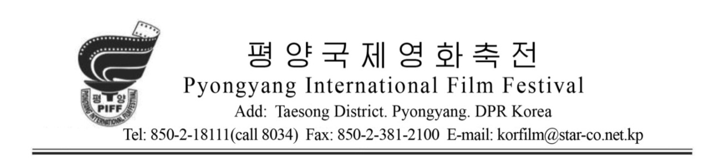

**Regulations for 18th Pyongyang International Film Festival**

1. Pyongyang International Film Festival is an annual international cultural event. Its aim is to develop the art of cinema by promoting exchange and cooperation between world film makers all over the world under the ideal of Independence, Peace and Friendship.

The 18th Pyongyang International Film Festival is being held from 22nd to 27th ,October, 2025, in Pyongyang, the capital city of DPR Korea.

2. Events of the festival are as follows.

1) Feature Film Competition

2) Documentary, Short Film and Animation Competition

3) Special Screening

4) Informative Screening

5) Film Exchange

3. Selection of the submitted films will be assigned to the Selecting Department of the Festival Organizing Committee.

1) Eligibility for Feature Film Competition

(1) The film must have been completed in and after January, 2024.

(2) The running time should be over 70 min.

2) Eligibility for Documentary, Short Film and Animation Competition

(1) The film must have been completed in and after January, 2024.

(2) No limit in the running time.

3) Eligibility for Special Screening

(1) Feature Films and Documentaries awarded in other international film festivals and highly appreciated at home and abroad can be presented.



(2) No limit in year of production and running time should be over 60

min.

4) Eligibility for Informative Screening

(1) It’s open to all kinds of films, such as feature film, short film, documentary, animation, etc.

(2) No limit in year of production and running time.

4. Any companies and individuals who are submitting films in the 18th Pyongyang International Film Festival should send the following materials to the Festival Organizing Committee until 15th August in 2025.

1) Application Form

2) Film Material for selection (in DVD, Hard Disks or USB)

3) In the preview, English subtitles are essential and, if you fail to enter English subtitles by circumstances, you should add transcript of the speech in English.

5. The Festival Organizing Committee will inform the result of selection within 30 days after receiving the above mentioned materials.

6. Applicants should send screening materials of the preview to the address of Festival Organizing Committee by 20th , September in 2025.

The screening material should be in HD type (avi, mp4 or mkv).

The film selected for competition must have an English subtitle.

The Festival Organizing Committee ensures the security of the film after the film has arrived in Pyongyang, returns the film materials to the submitters' side following the request of the copyright holders at the end of the festival, and does not return the DVD or USB media and posters sent for other film selection and the production of the art of the festival.



7. The Festival Organizing Committee has the right to reject films that doesn’t conform to the ideal of the festival.

8. The Festival Organizing Committee organizes Film Exchange to promote cooperation, technical exchange and distribution between film makers all over the world.

9. Prizes awarded in the Festival

1) Grand Prix 1

2) Awards for Feature Film Competition 11

(1) Best Screenplay

(2) Best Direction

(3) Best Photography

(4) Best Actor

(5) Best Actress

(6) Best Figurant

(7) Best Figurante

(8) Best Art

(9) Best Music

(10) Best Technique (Special Display Effect)

(11) Best Sound Effect

3) Best Documentary

4) Best Short Film

5) Best Animation

6) Special Jury Award

7) Special Award of the Festival Organizing Committee (The award goes to 2 films.)

8) Prize for Special Screening (The award goes to 5 films.)

10. The Festival Organizing Committee nominates the international jury of 5 members who are not concerned in production and distribution of the films presented in competition.



The Festival Organizing Committee bears the double fare and living expenses for the International Juries during the festival.

11. The Festival Organizing Committee bears the returning expenses of the screening materials.

12. Companies and individuals who are taking part in the Pyongyang International Film Festival should send their Application Forms or Applications for Film Exchange 40 days before the beginning of the festival.

13. The Film Organizing Committee bears double fare and living expenses for one member of the film delegation selected for the competition (2, if the director or the leading actor is involved) and living expenses for two members of the film delegation selected for the non-competition.

14. When the Festival Organizing Committee receives Festival Application and Entry Forms from organizations and individuals of different countries, it implies full acceptance of the festival regulation and decides submitting films and participating in the festival.

Once the film is submitted, it can’t be cancelled.

Organizing Committee of Pyongyang International Film Festival

Add: Ryonghungdong No.2, Taesong District, Pyongyang, DPR Korea

Tel: 850-2-18111 (341-8034)

E-mail: korfilm@star-co.net.kp

Fax: 850-2-381-2100/4410

http://www.korfilm.com.kp